CS/AI/CY/SE4092
Final Year Project
Project Title
Submitted By
Student 1 Ammar Hyder 22K-4816
Student 2 Ausaja Hussain 22K-5186
Student 3 Muhammad Abdullah 22K-5156
Project Progress Report
Department of Computer Science National University
of Computer and Emerging Sciences FAST Karachi Campus

INTRODUCTION
The recruitment industry is evolving rapidly, yet existing job portals often face challenges such as fraudulent postings, inefficient candidate matching, biased job descriptions, and time-consuming screening processes.
CareerForge addresses these issues through an AI-powered recruitment platform designed for Computer Science and IT professionals, offering features such as fraud detection, intelligent matching, and automated evaluation.
This document presents the progress of the CareerForge project in relation to its defined milestones. It evaluates the current status against the project timeline and outlines remaining tasks to ensure successful completion.

TIMELINE
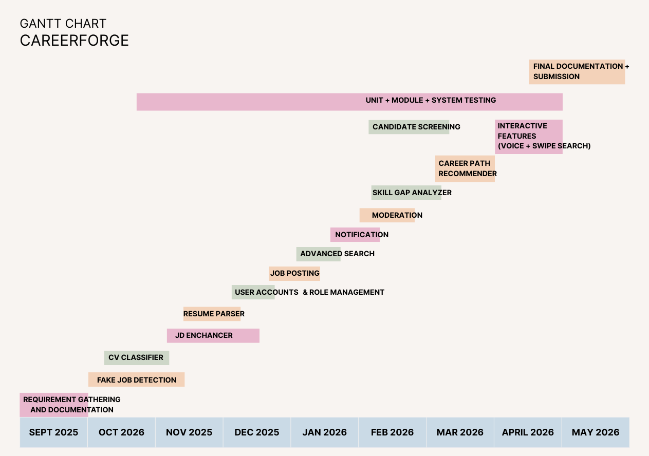

PROGRESS
This section must elaborate the current progress of the project with respect to milestone.

MILESTONE 1 PROGRESS
The sub-heading should be in Times New Roman, bold and uppercase with font size of 12.

MILESTONE 2 PROGRESS
The body Text should be in Times New Roman with Line-Spacing of 1.5 and Justified Alignment with Regular style.

MILESTONE 3 PROGRESS
List all the milestones from final exam to midterm of FYP part 2.

UPDATED TIMELINE
The section must visualize the timeline from proposal to completion of project.
REFERENCES

